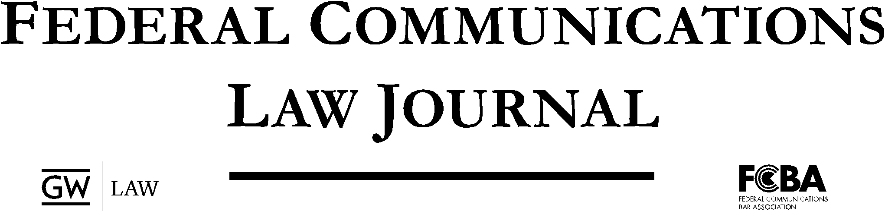
Volume 75
Editor-in-Chief
Julia Dacy

Senior Managing Editor  Rebecca Roberts | Senior Production Editor  Robin Briendel |  | Senior Articles Editor  Micah Leval
Senior Notes Editor  Thompson Hangen | Senior Publications Editor  Courtland Ingraham |  | Senior Projects Editor  Briana Whitmore
Managing Editor  Andrew Bearkland  Nicolas Florio | Production Editor  Max Matheu |  | Articles Editor  Adam Lindemulder  Garrett Dowell
 | Notes Editors
Delaney Dunn |  | Samantha Nardone | Patrick Walters

Diversity Chair
Briyana Louis
Associates
Dallin Albright | Glen Hisani | Alyssa Kurke | Juan Pazmiño
John Bogert | Sydney Huppert | Anthony Licata | Jamie Reiner
John Evans | Kelly Hutchinson | Gavin McClure | Avery Turzanski
Alan Harrison | Jonathan Johnson | Jacob Naim | Julia Wells
Julia Herring | Aleeza Kanner | Aditi Patil
 | Abraham Kim | Vaibhavi Patria

Members
Bernard Baffoe-Mensah | Colin Harmeyer | Seriana Saltzen
Emily Bernhard | Jordyn Johnson | Julianne Saunders
Zachary Burman | Sarah Lambert | David Silverman
Christina Cacioppo | Cassidy Lang | Benjamin Soullier
Robin Choi | Maxwell Lemen | Georgia Spies
Caleb Coffman | Alexander Logan | Henry Stanaford
Madison Decker | Austin Newman | Ileana Thompson
Lindsay Dittman | Elijah Pardo | James Van Drie
Benjamin Duwve | Tomasso Piccirilli | Katherine Wirvin
Angela Gasca | Simon Poser | Will Yu
Alexander Goodrich | Katherine Quinn | Yan Zhang
Amber Grant | Catherine Ryan | Winnie Zhong
Morgan Gray | Daniel Sachs

Faculty Advisors
Professor Arturo Carrillo | Professor Dawn Nunziato

Adjunct Faculty Advisors
Michael Beder  Tawanna Lee | Ethan Lucarelli  Meredith Rose

Published by the George Washington University Law School and the Federal Communications Bar Association

